Name: ________________________________ Date: ___________________________________

Class: _________________________________ Teacher: ___________________________________

# Math Mini Quiz 7

This Mini Quiz, we’re going to explore the math concepts that you’ve learned so far in this unit. This assignment should take you about **15 minutes**.

1) Below are two different quadratic equations. Solve for x. You may choose the method you’d like to solve it. As a reminder, the quadratic formula can be found to the right.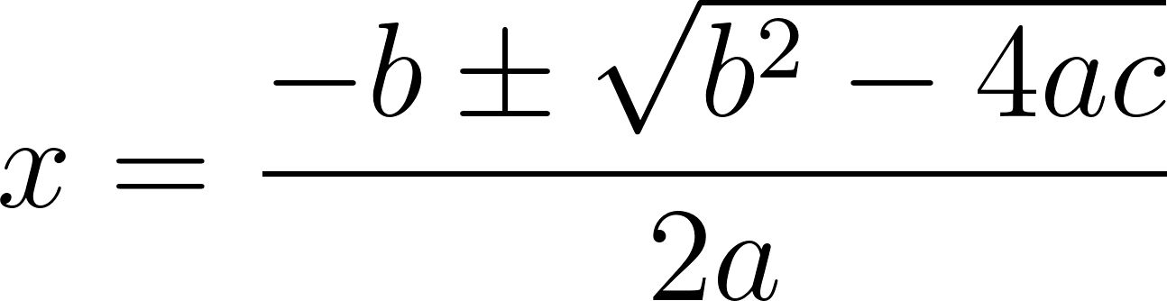

a) 7 = x2 - 13x + 17

*To start, we put zero on the on left side by subtracting 7*

*7 = x2 - 13x + 17*

*Now, we decide if we can factor it. This one we can, so we factor and find the and find the answer that way*

*0 = x2 - 13x + 10*

*0 = (x - 3)(x - 10)*

*0 = x - 3 →* ***x = 3***

*0 = x - 10 →* ***x = 10***

b) 0 = x2 - 3x + 7

*To start, we check that the zero is on the left side, which it already is*

*0 = x2 - 7x + 7*

*It’s not easy to see how to factor this, particularly since 7 is a prime number, so we’ll have to use the quadratic formula*

2) In 2002, Lisa Leslie became the first woman in the WNBA to dunk[1] during a game. Let’s think about the mechanics of this historic dunk. Let’s assume Leslie’s 2m tall. Let’s call the acceleration of gravity (g) to be 10. We therefore get the *height of the top of her head* during her jump as a function of time to be: 

Where is the height of the top of her head in meters and is the time after the start of her jump in seconds. Next let’s assume in order to dunk, the top of her head had to reach the bottom of the net, which stands 2.5 meters above the ground[2].

a) Assume she had been in the air 0.5 seconds when she made the dunk[3]. What was her initial vertical velocity, ? Write the equation for .

| *If she made the dunk at 0.5 seconds, then the top of her head was at y=2.5 meters above the ground, that means our equation goes through (0.5, 2.5). So, let’s plug (0.5, 2.5) into the equation given:*  *y(0.5) = 2.5= -5(0.5)²+v0(0.5)+2* | *We then solve for v0.*  *2.5= -5(0.5)²+v0(0.5)+2*  *0.5 = -5(0.5)²+v0(0.5)*  *1 = -5(0.5) + v0*  *v0=1+2.5=3.5 m/s → v0=3.5*  ***y(t) = -5t²+3.5t + 2*** |
| --- | --- |

b) At what time does she hit the ground again?

| *If she’s 2m tall, she’ll hit the ground when y(t)=2. So, we plug that in and solve for t*  *y(t) = 2 = -5t²+3.5t + 2*  *Solve for t*  *0 = -5t²+3.5t*  *0 = t(-5t + 3.5)* | *0=t*  *0=-5t + 3.5 → t =*  *We see there are two solutions, one of which being t=0 and the other being t=0.7. So, she leaves the ground at t=0 and she is back on the ground, having dunked* ***at 0.7 seconds.*** |
| --- | --- |

c) Lisa actually hits the 2.5m mark twice on her trajectory. Once on the way up and once on the way down. We talked about how one of these times is at 0.5 seconds. When does the other occur? Did she dunk on the way up or or on the way down?

| *To solve this, we plug 2.5 in for y and solve for t*  *y(t) = 2.5 = -5t²+3.5t + 2*  *0 = -5t²+3.5t - 0.5*  *We know one of the factors will be (t - 0.5), so we know we can factor the equation like:*  *0 = (t - 0.5)(-5t + 1)*  *Solving, we get*  *0 = -5t + 1*  *t = ⅕ = 0.2* | *So, she also hits 2.5 meters in 0.2 seconds. We can therefore say she dunked on the way down. This is because the first time she hits 2.5 meters will be the way up and the second time the way down. Since 0.2 < 0.5, we can assume that the way up was at 0.2 seconds and the way down was at 0.5 seconds, when she made the dunk.* |
| --- | --- |

1. Image and information from https://www.swishappeal.com/2015/9/11/9313199/lisa-leslie-dunk-hall-of-fame
2. Estimated from this information: https://www.dimensions.com/element/basketball-rims-nets
3. Based roughly on this calculator: https://www.thehoopsgeek.com/dunk-calculator/